**Assignment 3**

**Part 2: Implementing And Analyzing Cache Configurations in Gem5**

**Environment Setup and Install Dependencies:**

At the very first before processing the simulation, it is required to make the system updated and install all the necessary dependency software like python, scons, gcc and g++.

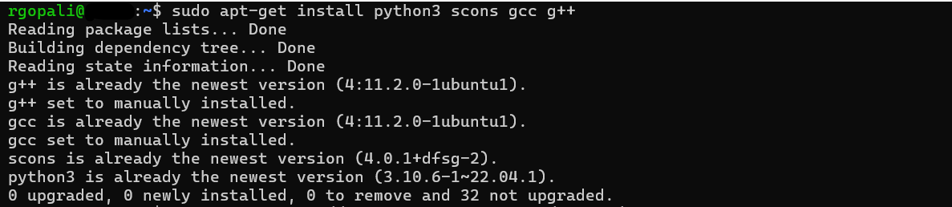

Once the system is ready with the dependencies, gem5 has been cloned and started building gem5 for x86 with the following code.

scons build/X86/gem5.opt -j4

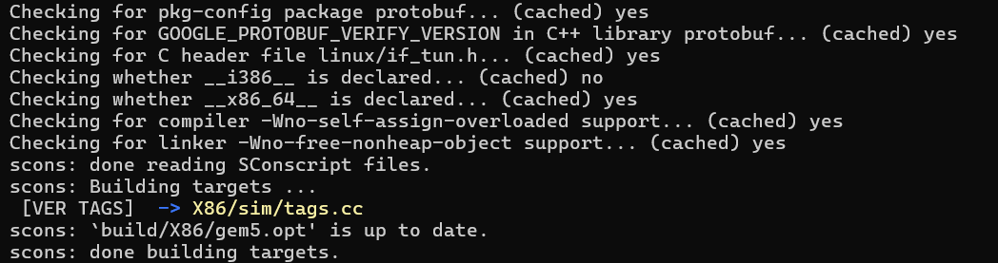

Now the hello "Hello World" Program has been written using Vim text editor and saved as ‘hello.c’.

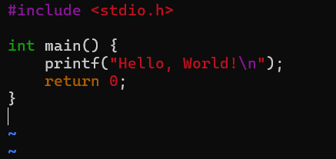

Once the program has been saved, it is compiled and executed to check whether there is any issue with the code or not.



To run this in gem5, a simple Python simulation script has been written and saved as ‘run_hello.py’.

Here, first, the required libraries are initialized and started with creating a ‘System’ object. Then, the clock and voltage domains are defined and later the types of the memory and its ranges are provided. A CPU configuration has been created and connecting the CPU and the memory. Finally, the workload has been set up and simulation codes for compilation have been written.

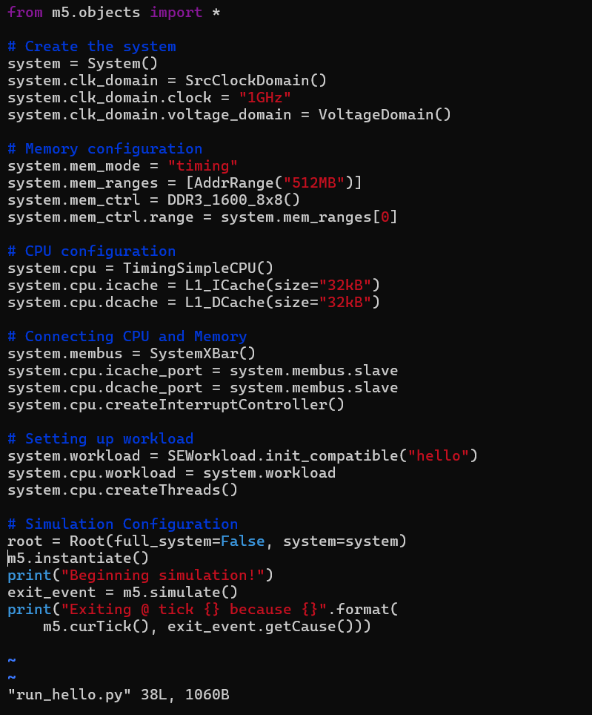

Finally, the Python code for the simulation runs with the following command.

./build/X86/gem5.opt configs/deprecated/example/se.py -c hello

